ASTRA: How to Check Room Availability for Academic Classroom Space
From the Main Astra launch page, click on Calendars Tab at the top.

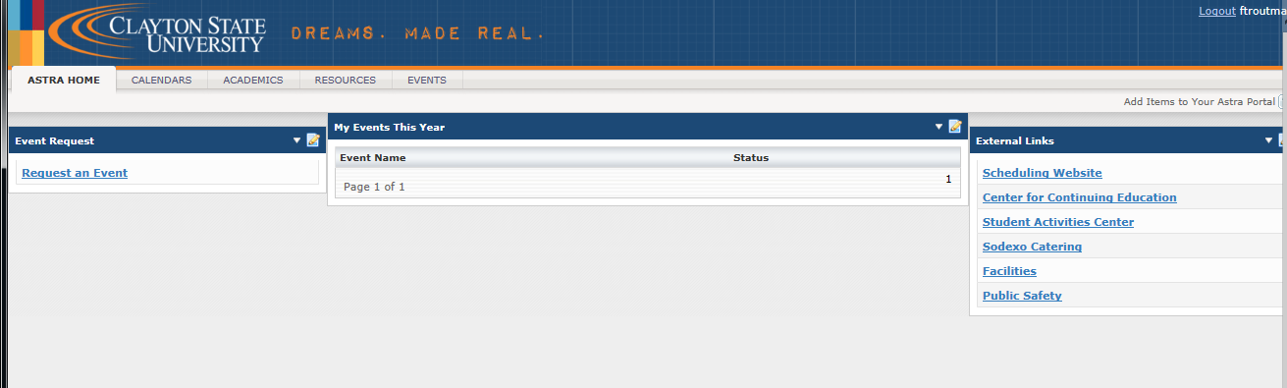

This will bring you to the Calendars page:

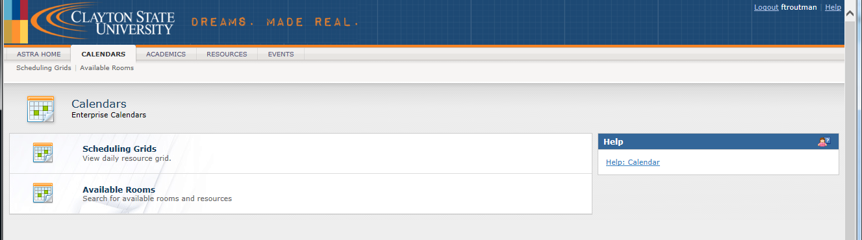

Select the “Available Rooms” link.

From the Available Room and Resource Tool screen, you will do an Available Rooms Search.

Select the “Add New” button (Under the Meeting(s) bar).

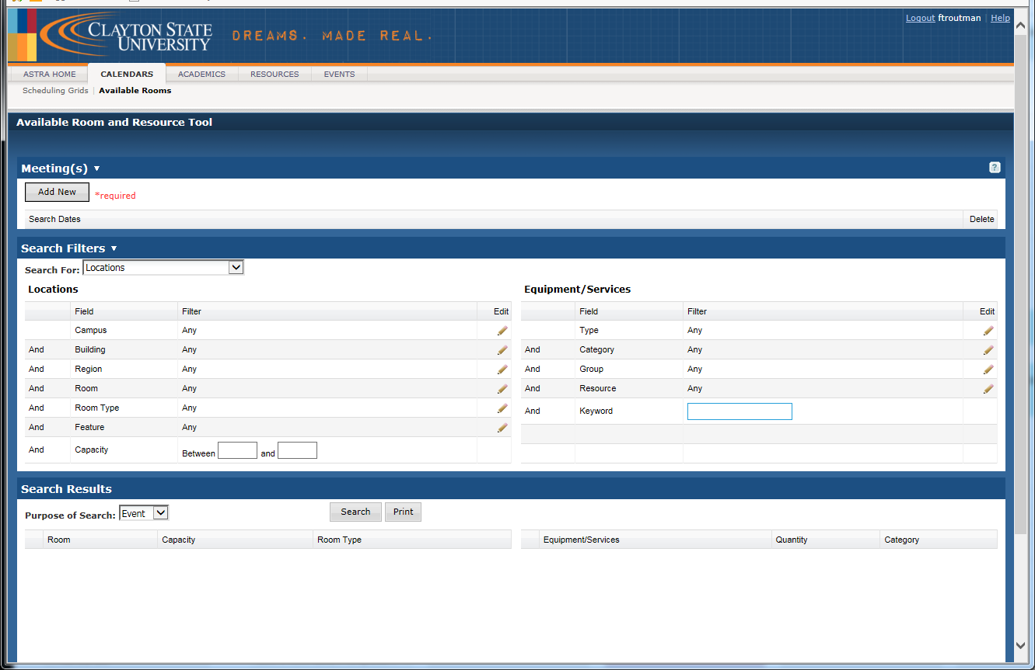

In the next selection/popup window, the “Add Meeting Window”, select the Single Meeting button or the “Recurring Meeting” button.

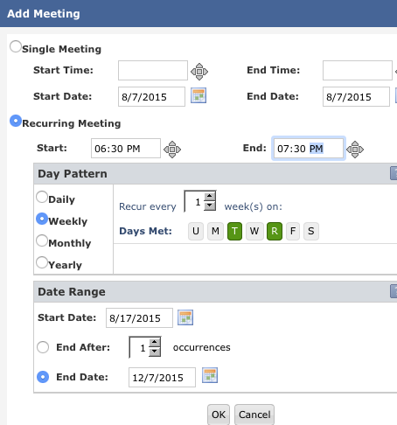
If the activity is recurring you will also need to input the Start and End time of the course and the “Day Pattern”.

You will also need to input the Date Range (i.e., the start and end dates of the semester).

Select “OK”.

Under the Search Filters bar, you will filter by Region.

Select Academic Classroom Space if you are searching for a room for academic course activities. (Note: You can also filter by Room, Building or Capacity).
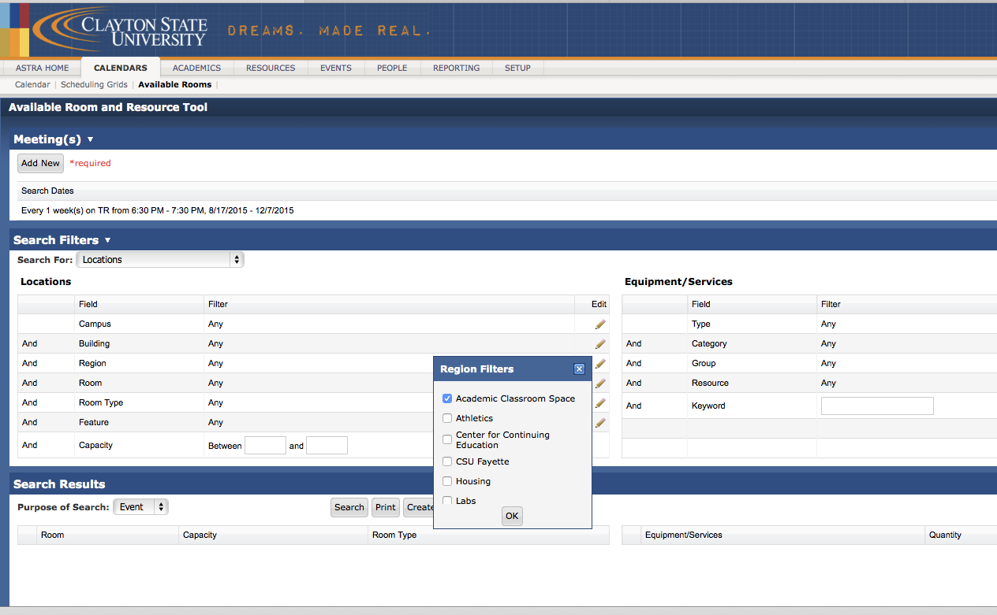
Select “Ok”.

Then under the Search Results area, indicate whether this search is for an Event or for a Course Section.

Then hit Search.
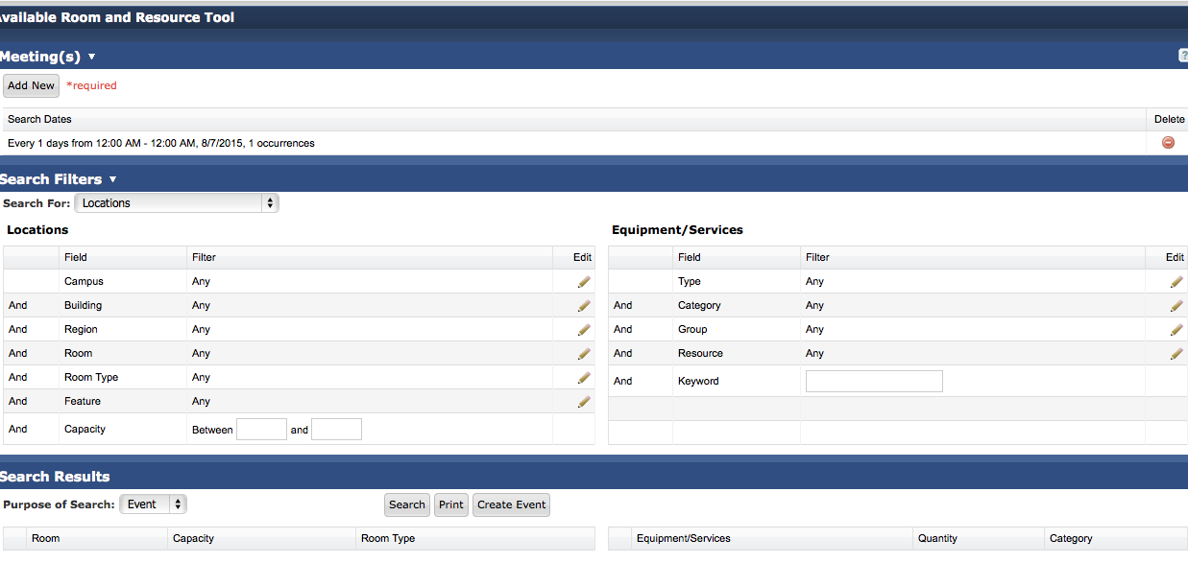

From the Search Results bar, select the space that best fits the classroom/instructional needs.
