SYLLABUS

COURSE TITLE/PREFIX/SECTION SEMESTER/ACADEMIC YEAR LOCATION/MODALITY DAY(S)/TIME

***INSTRUCTOR NAME & CREDENTIALS:***

Office Location:

Office Phone:

Email Address:

Office Hours:

***Course Description:***

***Key Learning Objectives:***

***Core IMPACTS Statement (if applicable):***

***Required Readings:***

***Attendance Policy:***

***Grading Procedures: Grading Scale***

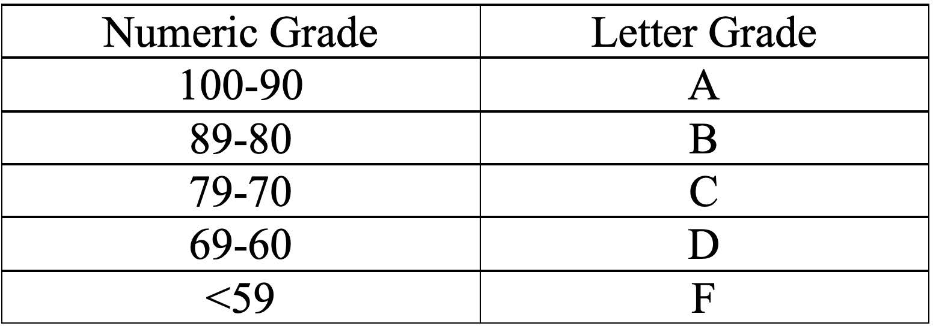

***Academic Integrity:*** Academic honesty is always required of all students. Correspondingly, cheating (which includes plagiarism) will not be tolerated. Refer to the specific policy in the Academic Catalog and Student Handbook. You are expected to read, know, and adhere to the stated policy.

Academic dishonesty is a serious offense and will be dealt with in accordance with the Clayton State University Student Handbook. All instances of academic misconduct will be reported to the Office of Community Standards. The minimum penalty will be a zero on the assignment for which academic misconduct occurs. As mentioned, plagiarism is one form of academic misconduct. If you copy someone else's work and don't give them credit, that is plagiarism, and it will be taken seriously.

***Plagiarism Detection Software:*** Students agree that by taking this course all required papers may be subject to submission for textual similarity review to Turnitin.com for the detection of plagiarism. All submitted papers will be included as source documents in the Turnitin.com reference database solely for the purpose of detecting plagiarism of such papers. You should submit your papers in such a way that no identifying information about you is included.

***Note:*** This course syllabus provides a general plan for the course. The instructor reserves the right to make deviations from the schedule if necessary.