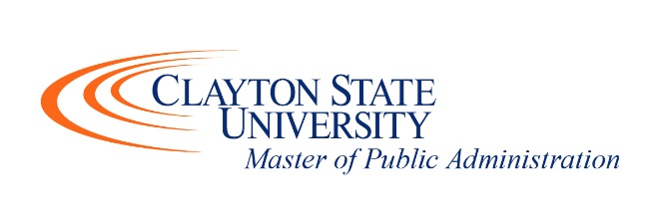

2021 MPA Curriculum Guide

Fall Semester
 | Course ID | Course Name | Part of Term
 | POLS 5010 | Public Administration | Short
 | POLS 5210 | Ethics in Public Administration | Short
 | POLS 5050 | Research Methods & Applied Stats | Full
 | POLS/CRJU _____ | Choose POLS/CRJU Elective | Short
 | POLS/CRJU _____ | Choose POLS/CRJU Elective | Short

Important Notes for Spring Semester:
Submit graduation application to Registrar by January 30th for Summer graduation.
Talk with program director during early spring about summer internship.

Spring Semester
 | Course ID | Course Name | Part of Term
 | POLS 6060 | Human Resource Management | Short
 | POLS 6250 | Organizational Theory & Management | Short
 | POLS 6230 | Local Government Admin & Finance | Short
 | POLS/CRJU _____ | Choose POLS/CRJU Elective | Short
 | POLS/CRJU _____ | Choose POLS/CRJU Elective | Short

Summer Semester
 | Course ID | Course Name | Part of Term
 | POLS 6940/POLS 6980 | Internship in Public Administration/Project in Public Administration | Full
 | POLS/CRJU_____ | Choose POLS/CRJU Elective | Full

*If you do not wish to complete the program using the accelerate format, contact Dr. Robinson (bryanrobinson@clayton.edu) for course sequencing recommendations.

