**ePROCUREMENT CHECKLIST**

**SPECIAL REQUEST**

**Item Details**

1. **Item Description**-this is your line item, should be the same as your quote. Make sure it is very descriptive. By putting a description of product or service helps to identify when you are inquiring on your requisition, no acronyms if possible. (Ex: Conference room chairs #Product 12345 for Budget & Finance) Make sure you are adding as many lines as your quote.
2. **Price-**please proof read to make sure the price and quantity has not been transposed
3. **Quantity**
4. **Unit of Measure**-use EA
5. **Category Field** Enter 5 ZEROS (00000) (putting any number other than 00000 will put your requisition in budget error)
6. **Supplier Name** Click magnifying glass to locate Supplier’s name under Short Supplier Name (click find). For New Supplier or Update Existing Supplier, please follow the instructions **Please verify you have entered the correct supplier.**
7. **Additional Information **REQUIRED\*\***

* **CSU Contact Name**
* **Phone Number**
* **Department**
* **Location where product should be delivered**
* **Quote #/Proposal #/Statewide Contract #**
* **Completion Date of service (NEW)**

1. **Ö “Send to Supplier” Box**
2. **Ö Add to Cart**
3. .Ö **Checkout (at top of page)**

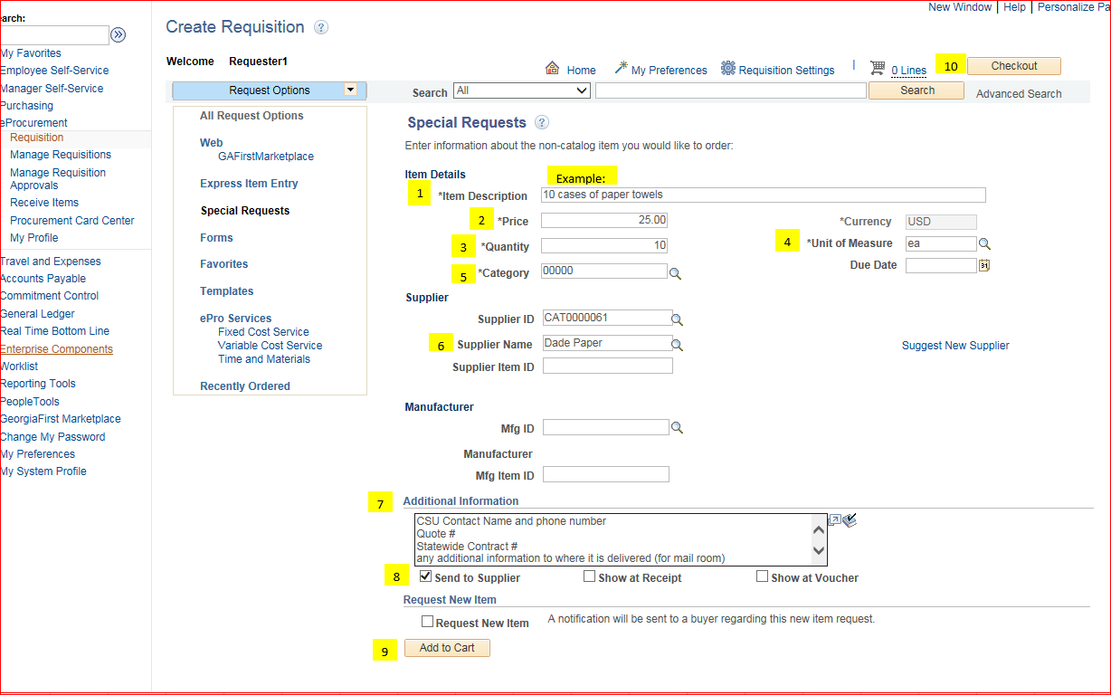

**SPECIAL REQUEST cont’d**

**Requisition Summary**

**11. Requisition Name**- description of purchase/service (Please name your requisition, it makes it easier to locate under “manage requisitions”)

**Cart Summary**

1. **Add Attachments** attach file under comments on line item (bubble)

**Supporting Documents to Attach**

* Final Contract, if it went through contract review (if applicable)
* Contractor’s Affidavit (> $2,500.00)
* Current Quote - not invoice
* Construction Contract (if applicable)
* Certificate of Insurance Eligibility (COI) if vendor performs service on campus

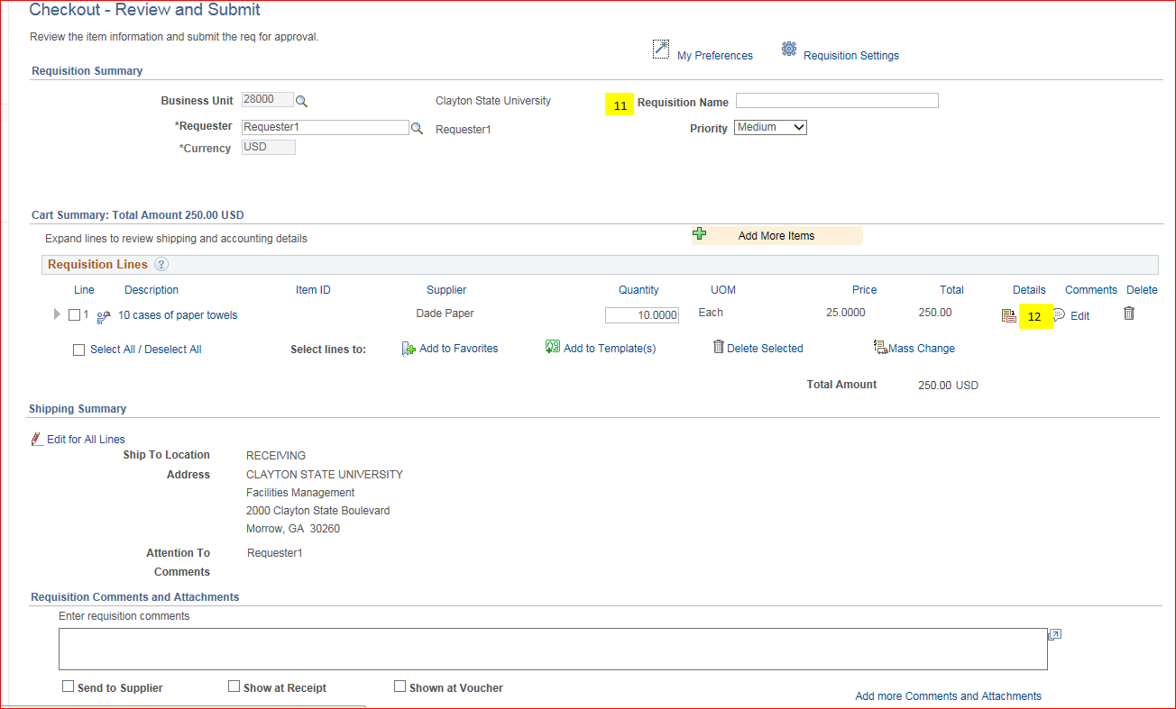

1. **Accounting Lines**

* **Chart field 2,** enter Fund Code, Department, Program, Class and Project. Please verify accounting string is correct
* **Chart field 3** (if project ID is required)
* **Asset Information** (if product is asset-single item over $3000.00) Enter AM Business Unit Field 28000 and Profile ID

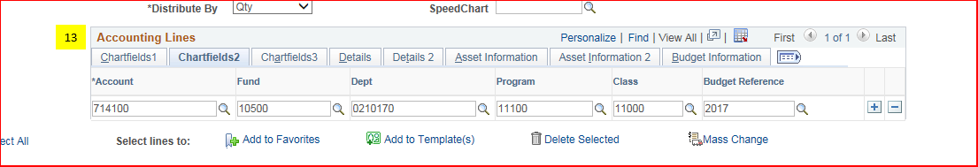

**Approval Justification**

1. **Justification/Comments Field** \*\***REQUIRED\*\***-put detailed business purpose for product/service.

**Save & Submit**

