Graduation Application – Paying out of Pocket
You have two options for paying the graduation application fee: out-of-pocket and via financial aid. If you choose out-of-pocket, please follow the instructions below.
STEP 1
- In the application instructions, click “click here to pay” (see image below).
- After payment is confirmed, save your order number. You will need it to complete the application submission process.
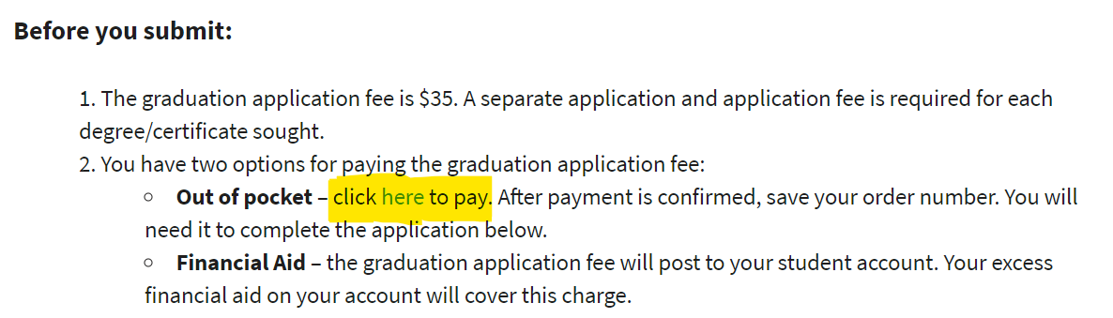
STEP 2

- Return to the graduation application.
- From the Method of Payment drop-down menu, choose “Pay out-of-pocket.”
- A field for the Order Number will appear (see image below). Enter the Order Number from your payment receipt.
- Complete the remaining parts of the application.
- Click Submit (upper right-hand corner).

